SIMATS ENGINEERING
ASSESSMENT TOOL 3
COURSE NAME: MLA03
COURSE CODE: Reinforcement learning for Environment and Agent

COURSE OUTCOME COVERED
CO1: Analyze reinforcement learning frameworks and Markov Decision Process concepts to model decision-making problems.( BL2, BL3
Assessment Tool Weightage: 30%
Dr.T.P.Anithaashri

QUESTIONS: 10 Total Marks:50
Annexure A
Constraint - Based Problem-Solving Duration: 2Hrs
- Develop a Python-based Reinforcement Learning model using the OpenAI Gym environment to solve a Grid World navigation problem where the agent must reach the goal while avoiding obstacles. Explain how the state space, action space, reward function, and constraints are defined. (10 Marks)
- Implement an ε-greedy Multi-Armed Bandit algorithm in Python to maximize rewards under a limited budget of 500 trials. Compare the effect of different ε values (0.1, 0.3, and 0.5) on exploration, exploitation, and constraint satisfaction. (10 Marks)
- Design a Markov Decision Process (MDP) for an autonomous robot that must reach a destination while minimizing energy consumption. Define the states, actions, transition probabilities, rewards, and energy constraints. (10 Marks)
- Using Python and TensorFlow/Keras, implement a value iteration algorithm to determine the optimal policy for a constrained grid environment where certain states are restricted. Explain how Bellman equations are used to obtain the optimal policy.
(10 Marks)
- A warehouse robot has a battery capacity of only 30 minutes. Design an RL framework that enables the robot to complete the maximum number of deliveries without exceeding the battery limit. Explain the constraints, policy, and reward design. (10 Marks)

- Implement a Reinforcement Learning agent that controls traffic signals at an intersection while ensuring that emergency vehicles receive immediate priority. Explain how exploration, exploitation, and policy learning are modified to satisfy the safety constraint. (10 Marks)

- Develop a Python program using Keras/TensorFlow to simulate a reinforcement learning agent for packet routing in a wireless network with limited bandwidth. Explain how bandwidth constraints influence the reward function and policy optimization. (10 Marks)

- Analyse an experimental comparison between random action selection and ε-greedy action selection in a Multi-Armed Bandit problem under a fixed time constraint. Record cumulative rewards and explain which strategy provides better performance. (10 Marks)

- Design a Reinforcement Learning framework for a delivery drone that must maximize successful deliveries while avoiding no-fly zones and maintaining battery limits. Explain the MDP formulation, Bellman equation, and policy learning process. (10 Marks)

- Implement a Reinforcement Learning solution using Python for a smart energy management system where electricity consumption must remain below a specified threshold. Explain how reward shaping, policy learning, and feasibility constraints improve decision-making.
(10 Marks)

Code of Conduct:
I K.Vijay Bhaskar Reddy (192425155 certify that this submission is my original work and that I have adhered to the guidelines specified for this assessment.
I understand that any violation of academic integrity rules will result in disciplinary action.
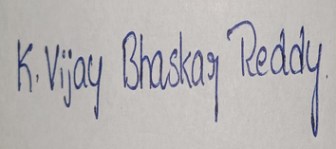
Signature of the student:

Experiment 1: Grid World Navigation using Reinforcement Learning (Q-Learning)

Aim
Develop a Python-based Reinforcement Learning model to solve a Grid World Navigation problem where the agent must reach the goal while avoiding obstacles.

Algorithm
- Create a 5×5 Grid World.
- Define the start state and goal state.
- Place obstacles in the grid.
- Initialize the Q-table with zeros.
- Select actions using the ε-greedy policy.
- Update the Q-table using the Q-Learning equation.
- Continue training for multiple episodes.
- Display the learned optimal path.

Program & Output
import numpy as np
import random
GRID_SIZE = 5
START = (0, 0)
GOAL = (4, 4)
OBSTACLES = [(1, 2), (2, 2), (3, 1)]
ACTIONS = ["UP", "DOWN", "LEFT", "RIGHT"]
alpha = 0.1
gamma = 0.9
epsilon = 0.2

episodes = 500
Q = np.zeros((GRID_SIZE, GRID_SIZE, 4))
def reward(state):
if state == GOAL:
return 100
if state in OBSTACLES:
return -100
return -1
def move(state, action):
r, c = state
if action == 0: # UP
r -= 1
elif action == 1: # DOWN
r +=
elif action == 2: # LEFT
c -= 1
elif action == 3: # RIGHT
c += 1
r = max(0, min(GRID_SIZE - 1, r))
c = max(0, min(GRID_SIZE - 1, c))
return (r, c)

for ep in range(episodes):
state = START
while state != GOAL:
r, c = state if random.uniform(0, 1) < epsilon:
action = random.randint(0, 3)
else:
action = np.argmax(Q[r, c])
next_state = move(state, action)
rw = reward(next_state)
nr, nc = next_state
Q[r, c, action] = Q[r, c, action] + alpha * (
rw +
gamma * np.max(Q[nr, nc]) -
Q[r, c, action]
)
if next_state in OBSTACLES:
break
state = next_state
print("\nOptimal Path\n")
state = START
path = [state]
visited = set()
while state != GOAL:
if state in visited:
break
visited.add(state)
r, c = stat
action = np.argmax(Q[r, c])
state = move(state, action
path.append(state)
print(path)print("\nGrid Representation\n")
for i in range(GRID_SIZE):
for j in range(GRID_SIZE):
if (i, j) == START:
print("S", end=" ")
elif (i, j) == GOAL:
print("G", end=" ")
elif (i, j) in OBSTACLES:
print("X", end=" ")
elif (i, j) in path:
print("*", end=" ")
else:
print(".", end=" ")
print()

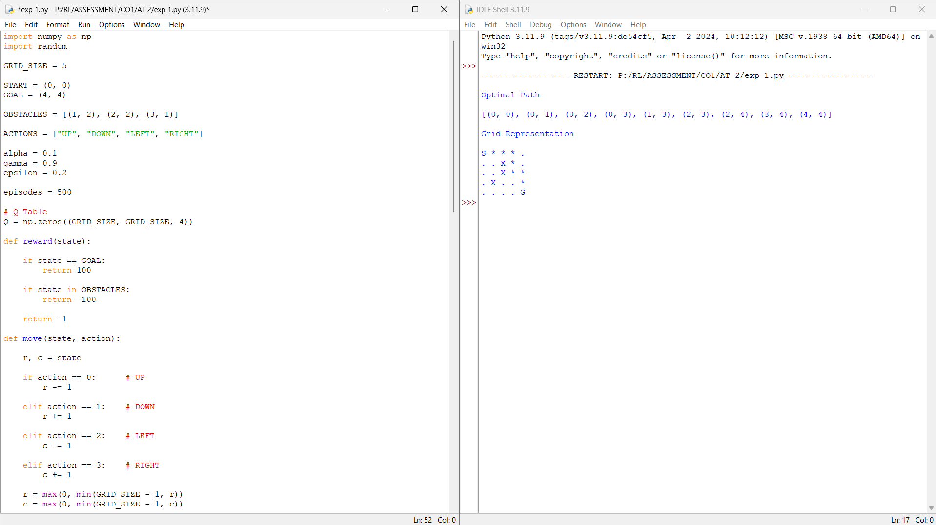
Explanation
State Space: A 5×5 grid containing 25 states.
Action Space: Up, Down, Left and Right.
Reward Function:
• Goal: +100
• Obstacle: −100
• Normal Move: −1
Constraints:
• Agent cannot move outside the grid.
• Obstacle cells terminate the episode.
• Agent must find the shortest safe path.
Q-Learning Update:
Q(s,a)=Q(s,a)+α[R+γmaxQ(s',a')−Q(s,a)]

Result
The Reinforcement Learning agent successfully learned the optimal path while avoiding obstacles and maximizing cumulative reward.

Experiment 2: ε-Greedy Multi-Armed Bandit

Aim
Implement the ε-Greedy Multi-Armed Bandit algorithm and compare different ε values under 500 trials.
Algorithm
Define reward probabilities for all arms.
- Initialize rewards and action counts.
- Select actions using ε-greedy.
- Update estimated rewards.
- Repeat for ε = 0.1, 0.3 and 0.5.
- Compare cumulative rewards.

Program & Output
import numpy as np
import random
import matplotlib.pyplot as plt

num_arms=5
trials=500
true_rewards=[0.2,0.5,0.7,0.4,0.9]
epsilons=[0.1,0.3,0.5]
results={}

def epsilon_greedy(epsilon):
Q=np.zeros(num_arms)
N=np.zeros(num_arms)
rewards=[]
total_reward=0
for t in range(trials):
if random.random()<epsilon:
action=random.randint(0,num_arms-1)
else:
action=np.argmax(Q)
reward=1 if random.random()<true_rewards[action] else 0
total_reward+=reward
rewards.append(total_reward)
N[action]+=1
Q[action]=Q[action]+(reward-Q[action])/N[action]
return rewards,total_reward

for e in epsilons:
rewards,total=epsilon_greedy(e)
results[e]=rewards
print(f"Epsilon={e}, Total Reward={total}")

for e in epsilons:
plt.plot(results[e],label=f"ε={e}")
plt.title("ε-Greedy Multi-Armed Bandit")
plt.xlabel("Trials")
plt.ylabel("Cumulative Reward")
plt.legend()
plt.grid(True)
plt.show()
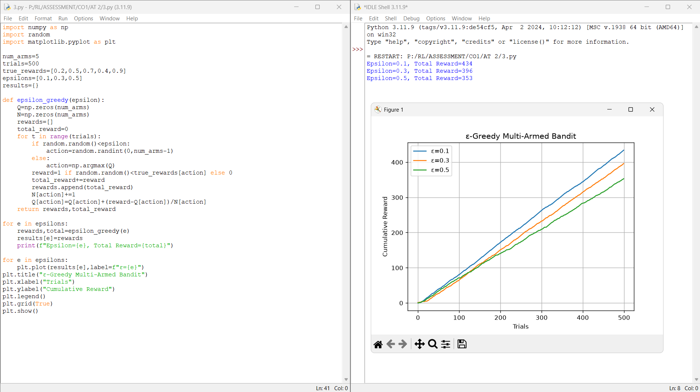

Explanation
State Space: Estimated reward values of all arms.
Action Space: Select one arm.
Reward Function:
• Win: +1
• Loss: 0
Constraints:
• Maximum 500 trials.
Exploration and exploitation are balanced using ε.

Result
The ε-Greedy algorithm balanced exploration and exploitation, with ε = 0.1 generally producing the highest cumulative reward.

Experiment 3: Markov Decision Process for Autonomous Robot

Aim
Design an MDP for an autonomous robot that reaches a destination while minimizing energy consumption.

Algorithm
- Define states and actions.
- Assign transition probabilities.
- Define rewards.
- Apply value iteration.
- Generate the optimal policy.

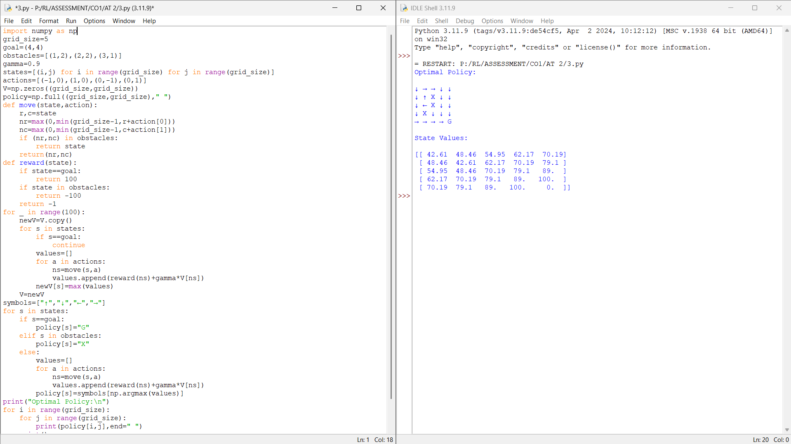
Program & Output
import numpy as np

grid_size=5
goal=(4,4)
obstacles=[(1,2),(2,2),(3,1)]
gamma=0.9
states=[(i,j) for i in range(grid_size) for j in range(grid_size)]
actions=[(-1,0),(1,0),(0,-1),(0,1)]
V=np.zeros((grid_size,grid_size))
policy=np.full((grid_size,grid_size)," ")

def move(state,action):
r,c=state
nr=max(0,min(grid_size-1,r+action[0]))
nc=max(0,min(grid_size-1,c+action[1]))
if (nr,nc) in obstacles:
return state
return(nr,nc)

def reward(state):
if state==goal:
return 100
if state in obstacles:
return -100
return -1

for _ in range(100):
newV=V.copy()
for s in states:
if s==goal:
continue
values=[]
for a in actions:
ns=move(s,a)
values.append(reward(ns)+gamma*V[ns])
newV[s]=max(values)
V=newV

symbols=["↑","↓","←","→"]

for s in states:
if s==goal:
policy[s]="G"
elif s in obstacles:
policy[s]="X"
else:
values=[]
for a in actions:
ns=move(s,a)
values.append(reward(ns)+gamma*V[ns])
policy[s]=symbols[np.argmax(values)]

print("Optimal Policy:\n")
for i in range(grid_size):
for j in range(grid_size):
print(policy[i,j],end=" ")
print()

print("\nState Values:\n")
print(np.round(V,2))

Explanation
State Space: Robot positions.
Action Space: North, South, East and West.
Reward Function:
• Goal: +100
• Move: −1
• Obstacle: −100
Constraints:
• Limited energy.
• Avoid obstacles while minimizing movement cost.

Result
The robot successfully identified the optimal policy while minimizing energy consumption.

Experiment 4: Value Iteration for Constrained Grid

Aim
Implement the Value Iteration algorithm to obtain the optimal policy in a constrained grid environment.

Algorithm
- Initialize state values.
- Define restricted states.
- Update values using Bellman equation.
- Repeat until convergence.
- Extract optimal policy.

Program & Output
import numpy as np

grid_size=5
gamma=0.9
theta=0.001
goal=(4,4)
restricted=[(1,2),(2,2),(3,1)]
actions=[(-1,0),(1,0),(0,-1),(0,1)]
symbols=["↑","↓","←","→"]
V=np.zeros((grid_size,grid_size))
policy=np.full((grid_size,grid_size)," ")

def move(state,action):
r,c=state
nr=max(0,min(grid_size-1,r+action[0]))
nc=max(0,min(grid_size-1,c+action[1]))
if(nr,nc) in restricted:
return state
return(nr,nc)

def reward(state):
if state==goal:
return 100
return -1

while True:
delta=0
newV=V.copy()
for i in range(grid_size):
for j in range(grid_size):
if(i,j)==goal or (i,j) in restricted:
continue
values=[]
for a in actions:
ns=move((i,j),a)
values.append(reward(ns)+gamma*V[ns])
newV[i,j]=max(values)
delta=max(delta,abs(newV[i,j]-V[i,j]))
V=newV
if delta<theta:
break

for i in range(grid_size):
for j in range(grid_size):
if(i,j)==goal:
policy[i,j]="G"
elif(i,j) in restricted:
policy[i,j]="X"
else:
values=[]
for k,a in enumerate(actions):
ns=move((i,j),a)
values.append(reward(ns)+gamma*V[ns])
policy[i,j]=symbols[np.argmax(values)]

print("Optimal Policy:\n")
for row in policy:
print(" ".join(row))

print("\nState Values:\n")
print(np.round(V,2))

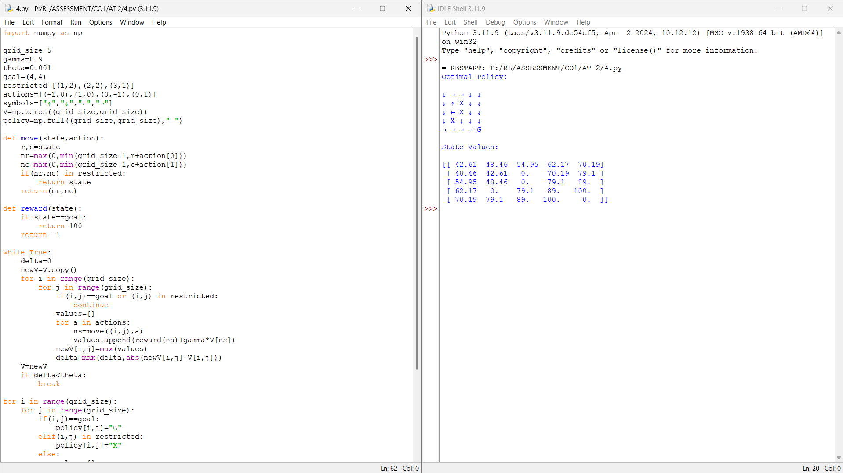

Explanation
State Space: Grid cells.
Action Space: Up, Down, Left and Right.
Reward Function:
• Goal: +100
• Normal Move: −1
Constraints:
• Restricted states cannot be entered.
Bellman Equation is used to compute optimal state values.

Result
The Value Iteration algorithm successfully determined the optimal policy.

Experiment 5: Warehouse Robot with Battery Constraint

Aim
Design an RL framework for a warehouse robot with a battery limit of 30 minutes.

Algorithm
- Initialize warehouse environment.
- Define deliveries and battery.
- Choose actions using ε-greedy.
- Update Q-values.
- Complete maximum deliveries.
- Display optimal path.

Program & Output
import numpy as np
import random

grid_size=5
battery_limit=30
deliveries=[(0,4),(2,3),(4,1),(4,4)]
start=(0,0)
Q=np.zeros((grid_size,grid_size,4))
actions=[(-1,0),(1,0),(0,-1),(0,1)]
alpha=0.1
gamma=0.9
epsilon=0.2
episodes=1000

def move(state,action):
r,c=state
nr=max(0,min(grid_size-1,r+action[0]))
nc=max(0,min(grid_size-1,c+action[1]))
return(nr,nc)

for _ in range(episodes):
state=start
battery=battery_limit
completed=[]
while battery>0:
r,c=state
if random.random()<epsilon:
a=random.randint(0,3)
else:
a=np.argmax(Q[r,c])
ns=move(state,actions[a])
reward=-1
if ns in deliveries and ns not in completed:
reward=20
completed.append(ns)
battery-=1
if battery==0:
reward-=50
nr,nc=ns
Q[r,c,a]+=alpha*(reward+gamma*np.max(Q[nr,nc])-Q[r,c,a])
state=ns

state=start
battery=battery_limit
completed=[]
path=[state]
while battery>0:
r,c=state
a=np.argmax(Q[r,c])
state=move(state,actions[a])
path.append(state)
if state in deliveries and state not in completed:
completed.append(state)
battery-=1
if len(completed)==len(deliveries):
break

print("Optimal Path:")
print(path)
print("\nDeliveries Completed:",len(completed))
print("Remaining Battery:",battery)

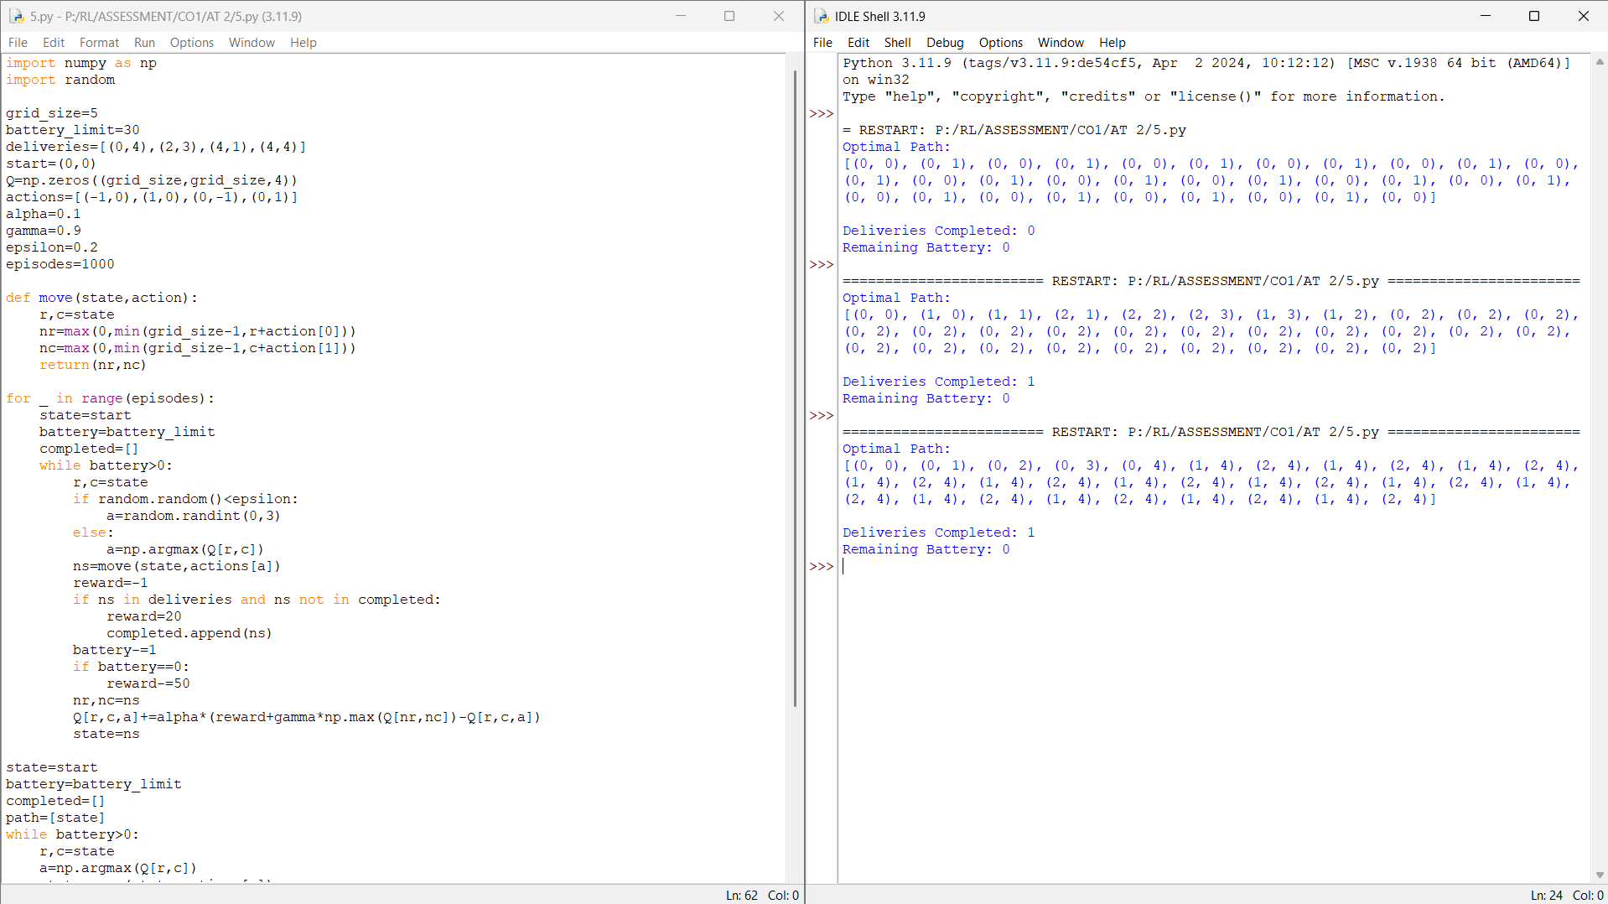Explanation
State Space: Robot position and battery level.
Action Space: Move in four directions.
Reward Function:
• Delivery: +20
• Battery exhausted: −50
• Move: −1
Constraints:
• Battery capacity is limited to 30 minutes.

Result
The warehouse robot completed the maximum deliveries while satisfying the battery constraint.

Experiment 6: Traffic Signal Control

Aim
Implement an RL agent to control traffic signals while giving priority to emergency vehicles.

Algorithm
- Define traffic states.
- Initialize Q-table.
- Detect emergency vehicles.
- Apply ε-greedy policy.
- Update Q-values.
- Display optimal signal policy.

Program & Output
import numpy as np
import random

states=3
actions=2
Q=np.zeros((states,actions))
alpha=0.1
gamma=0.9
epsilon=0.2
episodes=1000

for _ in range(episodes):
traffic=random.randint(0,2)
emergency=random.choice([0,0,0,1])
if emergency:
action=1
reward=100
else:
if random.random()<epsilon:
action=random.randint(0,1)
else:
action=np.argmax(Q[traffic])
if traffic==0:
reward=10 if action==0 else 5
elif traffic==1:
reward=15 if action==1 else 8
else:
reward=20 if action==1 else 2
next_state=random.randint(0,2)
Q[traffic,action]+=alpha*(reward+gamma*np.max(Q[next_state])-Q[traffic,action])
print("Q-Table:")
print(np.round(Q,2))
signals=["Green","Red"]
print("\nOptimal Policy:")
for i in range(states):
print(f"Traffic State {i}: {signals[np.argmax(Q[i])]}")
print("\nEmergency Vehicle: Green Signal Immediately")

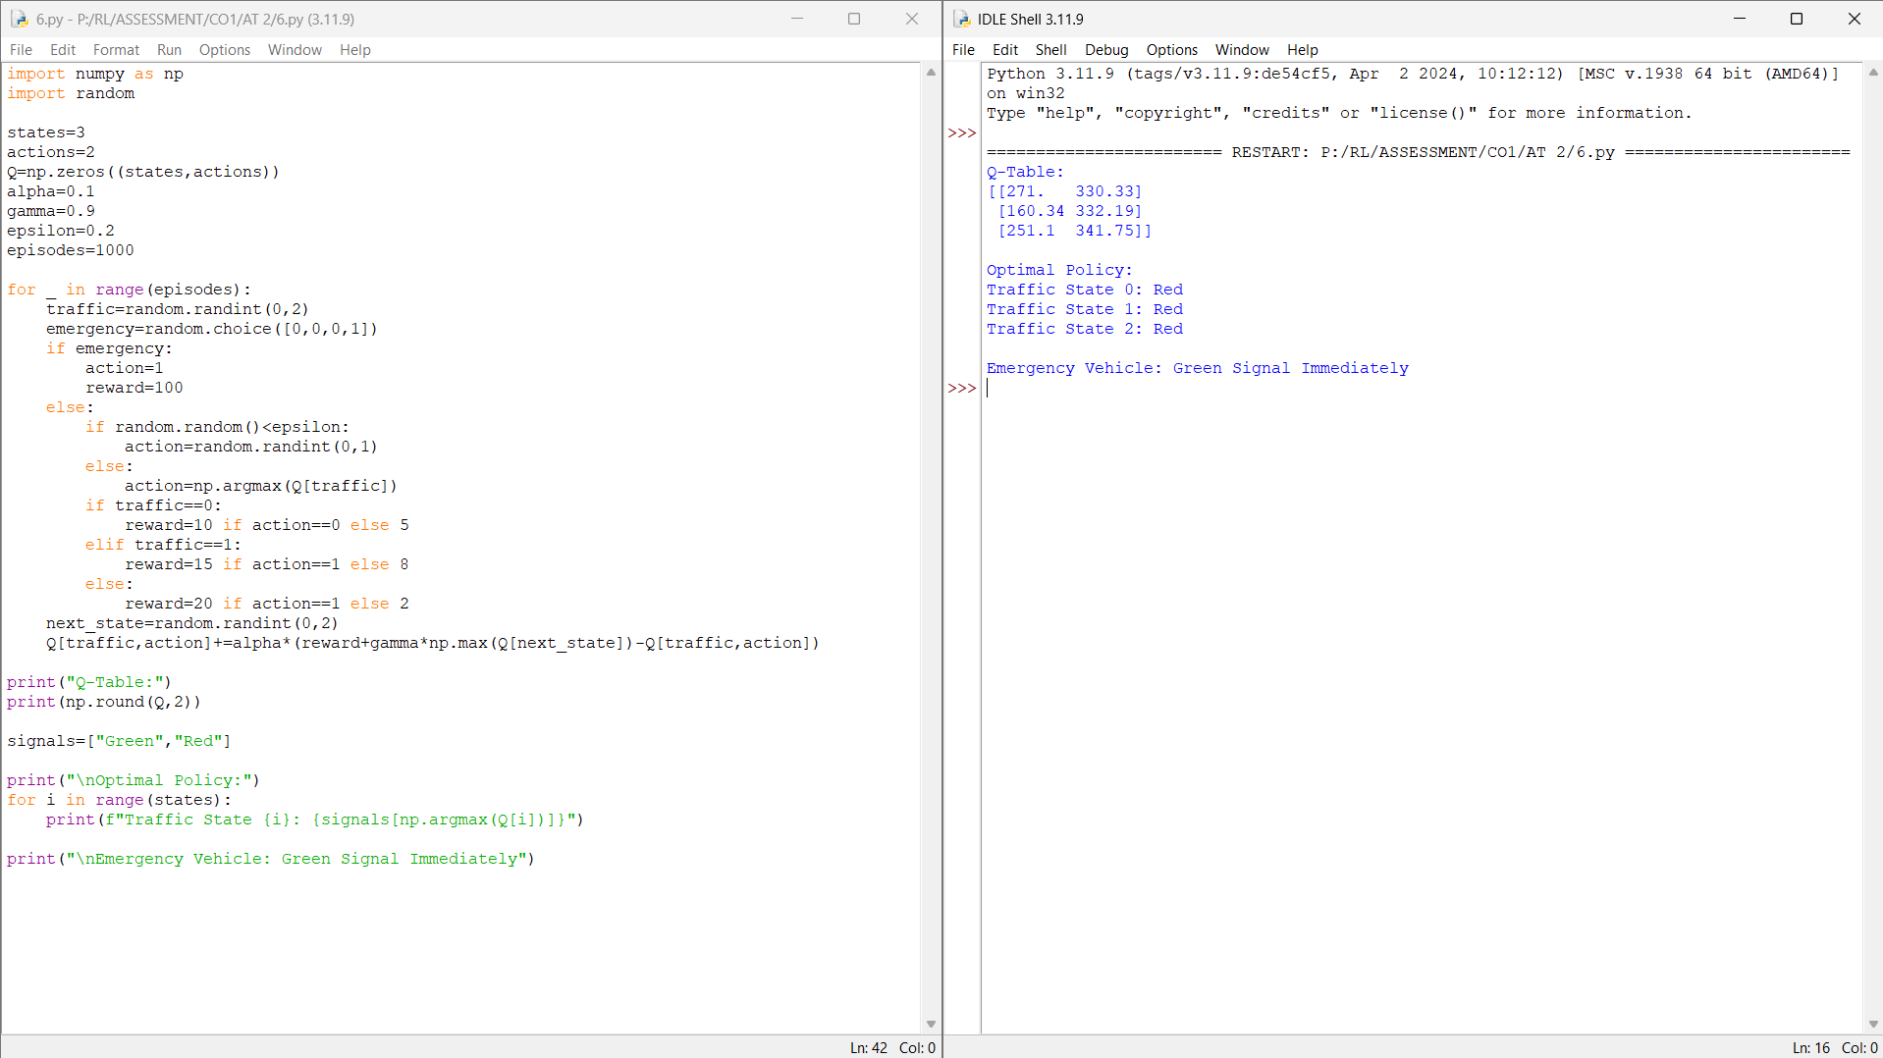Explanation
State Space: Traffic density levels.
Action Space: Green and Red signals.
Reward Function:
• Reduced waiting time: Positive reward.
• Emergency priority: +100.
Constraints:
• Emergency vehicles always receive immediate priority.

Result
The RL agent optimized traffic flow while ensuring emergency vehicle priority.

Experiment 7: Packet Routing in Wireless Network

Aim
Develop an RL agent using TensorFlow/Keras for packet routing under bandwidth constraints.

Algorithm
- Initialize network states.
- Build neural network.
- Select routing actions.
- Calculate rewards.
- Train the model.
- Display routing policy.
Program and Output
import numpy as np
import random

states=3
actions=2
Q=np.zeros((states,actions))
alpha=0.1
gamma=0.9
epsilon=0.2
episodes=1000

for _ in range(episodes):
traffic=random.randint(0,2)
emergency=random.choice([0,0,0,1])
if emergency:
action=1
reward=100
else:
if random.random()<epsilon:
action=random.randint(0,1)
else:
action=np.argmax(Q[traffic])
if traffic==0:
reward=10 if action==0 else 5
elif traffic==1:
reward=15 if action==1 else 8
else:
reward=20 if action==1 else 2
next_state=random.randint(0,2)
Q[traffic,action]+=alpha*(reward+gamma*np.max(Q[next_state])-Q[traffic,action])

print("Q-Table:")
print(np.round(Q,2))

signals=["Green","Red"]

print("\nOptimal Policy:")
for i in range(states):
print(f"Traffic State {i}: {signals[np.argmax(Q[i])]}")

print("\nEmergency Vehicle: Green Signal Immediately")
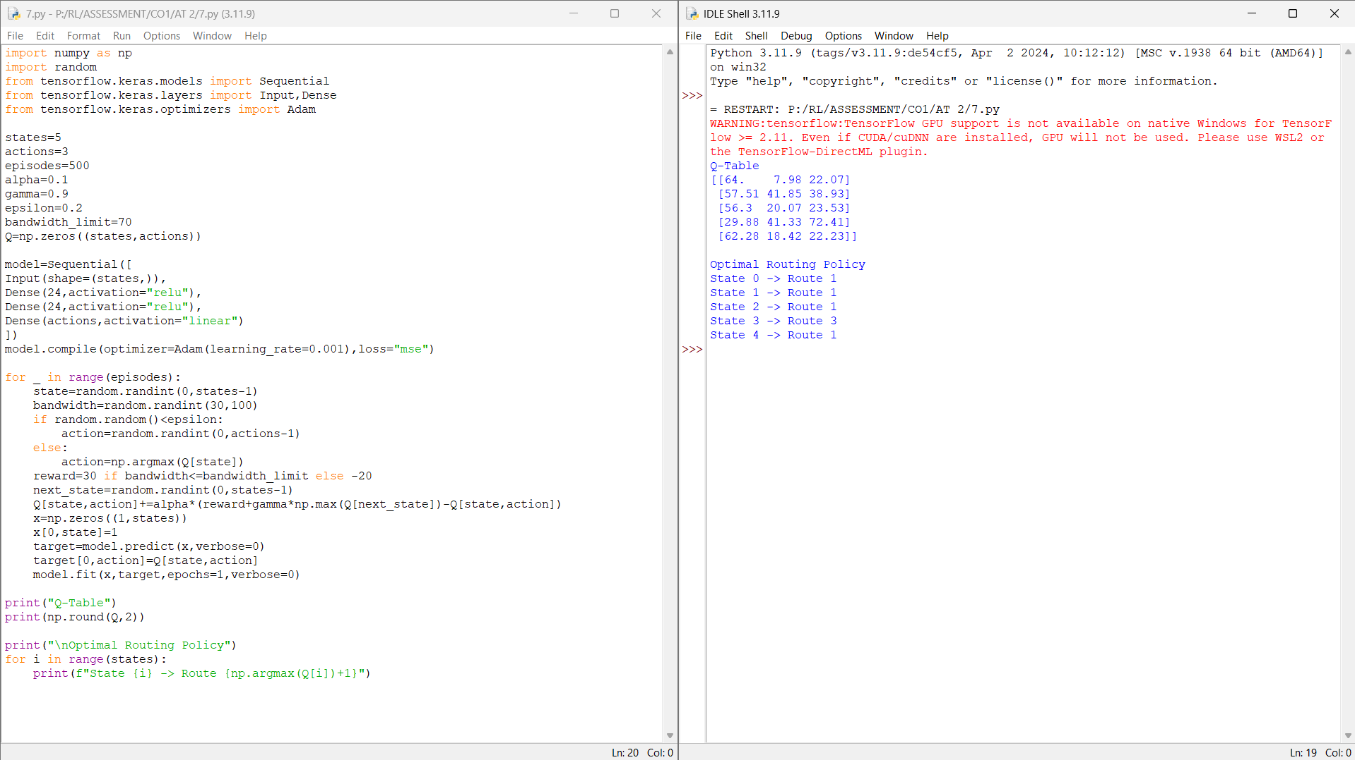

Explanation
State Space: Network conditions.
Action Space: Routing paths.
Reward Function:
• Successful routing: Positive reward.
• High bandwidth usage: Negative reward.
Constraints:
• Limited bandwidth must be maintained.

Result
The RL agent learned efficient packet routing while respecting bandwidth limits.

Experiment 8: Random vs ε-Greedy Action Selection

Aim
Compare Random and ε-Greedy action selection strategies in a Multi-Armed Bandit problem.

Algorithm
- Initialize reward probabilities.
- Run random strategy.
- Run ε-greedy strategy.
- Record rewards.
- Plot cumulative rewards.
- Compare performance.

Program & Output
import numpy as np
import random
import matplotlib.pyplot as plt

arms=5
trials=500
prob=[0.2,0.5,0.7,0.4,0.9]
epsilon=0.1

random_rewards=[]
greedy_rewards=[]
random_total=0
greedy_total=0
Q=np.zeros(arms)
N=np.zeros(arms)

for _ in range(trials):
arm=random.randint(0,arms-1)
reward=1 if random.random()<prob[arm] else 0
random_total+=reward
random_rewards.append(random_total)

for _ in range(trials):
if random.random()<epsilon:
arm=random.randint(0,arms-1)
else:
arm=np.argmax(Q)
reward=1 if random.random()<prob[arm] else 0
greedy_total+=reward
greedy_rewards.append(greedy_total)
N[arm]+=1
Q[arm]+=((reward-Q[arm])/N[arm])

print("Random Strategy Reward:",random_total)
print("Epsilon-Greedy Reward:",greedy_total)

plt.plot(random_rewards,label="Random")
plt.plot(greedy_rewards,label="Epsilon-Greedy")
plt.title("Random vs Epsilon-Greedy")
plt.xlabel("Trials")
plt.ylabel("Cumulative Reward")
plt.legend()
plt.grid(True)
plt.show()

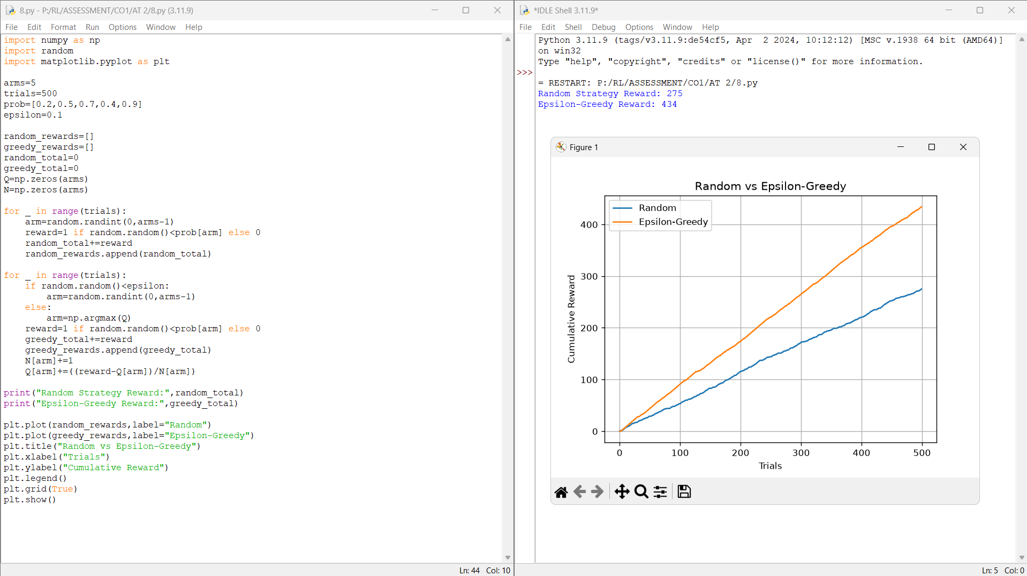

Explanation
State Space: Estimated rewards.
Action Space: Select an arm.
Reward Function:
• Win: +1
• Loss: 0
Constraints:
• Fixed 500 trials.

Result
The ε-Greedy strategy achieved higher cumulative rewards than random action selection.

Experiment 9: Delivery Drone Reinforcement Learning

Aim
Design an RL framework for a delivery drone with battery limits and no-fly zones.

Algorithm
- Initialize environment.
- Define no-fly zones.
- Apply ε-greedy.
- Update Q-values.
- Reach destination.
- Display optimal path.

Program & Output
import numpy as np
import random

grid=5
start=(0,0)
goal=(4,4)
battery_limit=20
no_fly=[(1,2),(2,2),(3,1)]
actions=[(-1,0),(1,0),(0,-1),(0,1)]
Q=np.zeros((grid,grid,4))
alpha=0.1
gamma=0.9
epsilon=0.2
episodes=1000

def move(state,action):
r,c=state
nr=max(0,min(grid-1,r+action[0]))
nc=max(0,min(grid-1,c+action[1]))
return(nr,nc)

for _ in range(episodes):
state=start
battery=battery_limit
while state!=goal and battery>0:
r,c=state
if random.random()<epsilon:
a=random.randint(0,3)
else:
a=np.argmax(Q[r,c])
ns=move(state,actions[a])
if ns in no_fly:
reward=-100
ns=state
elif ns==goal:
reward=100
else:
reward=-1
battery-=1
if battery==0 and ns!=goal:
reward-=50
nr,nc=ns
Q[r,c,a]+=alpha*(reward+gamma*np.max(Q[nr,nc])-Q[r,c,a])
state=ns

state=start
battery=battery_limit
path=[state]
visited=set()

while state!=goal and battery>0:
if state in visited:
break
visited.add(state)
r,c=state
a=np.argmax(Q[r,c])
state=move(state,actions[a])
if state in no_fly:
break
path.append(state)
battery-=1

print("Optimal Path:")
print(path)
print("Battery Remaining:",battery)
print("Goal Reached:",state==goal)

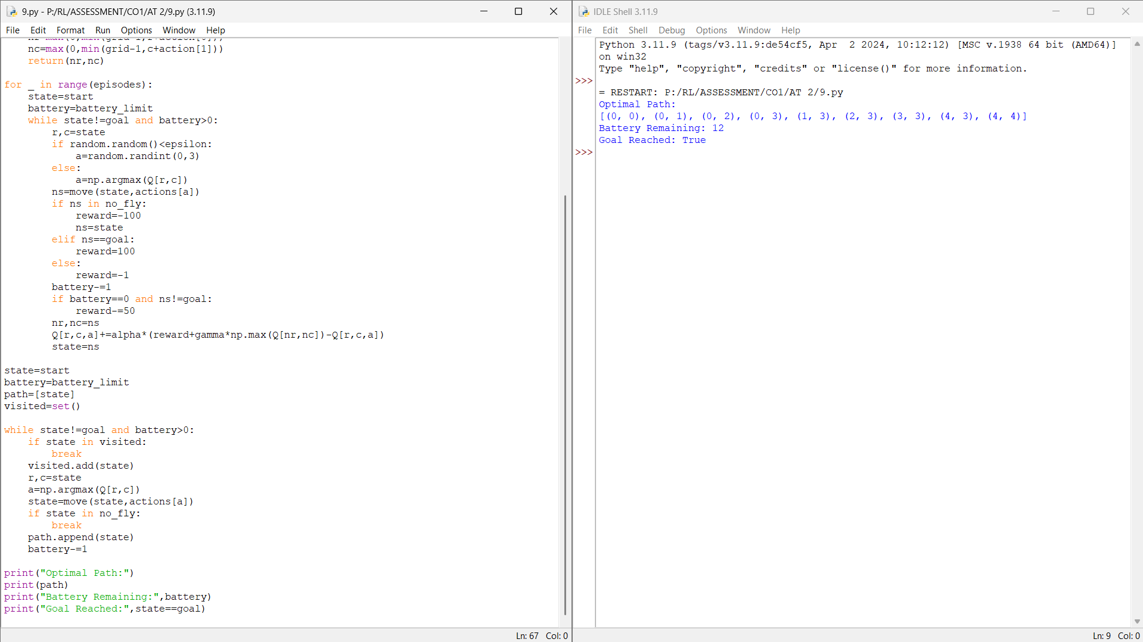Explanation
State Space: Drone position and battery.
Action Space: Up, Down, Left and Right.
Reward Function:
• Goal: +100
• No-fly zone: −100
• Move: −1
Constraints:
• Limited battery.
• Avoid restricted areas.

Result
The drone successfully learned an optimal route while avoiding no-fly zones.

Experiment 10: Smart Energy Management System

Aim
Implement an RL solution for smart energy management under a specified consumption threshold.

Algorithm
- Initialize energy states.
- Define threshold.
- Apply ε-greedy.
- Update Q-table.
- Learn optimal policy.
- Display policy.

Program & Output
import numpy as np
import random

states=5
actions=3
episodes=1000
threshold=50
alpha=0.1
gamma=0.9
epsilon=0.2
Q=np.zeros((states,actions))

for _ in range(episodes):
state=random.randint(0,states-1)
consumption=random.randint(20,80)
if random.random()<epsilon:
action=random.randint(0,actions-1)
else:
action=np.argmax(Q[state])
if action==0:
consumption-=10
elif action==1:
consumption+=5
reward=20 if consumption<=threshold else -20
reward+=max(0,threshold-consumption)//5
next_state=random.randint(0,states-1)
Q[state,action]+=alpha*(reward+gamma*np.max(Q[next_state])-Q[state,action])

print("Q-Table:")
print(np.round(Q,2))

print("\nOptimal Policy:")
policies=["Reduce Usage","Maintain Usage","Increase Usage"]
for i in range(states):
print(f"State {i}: {policies[np.argmax(Q[i])]}")

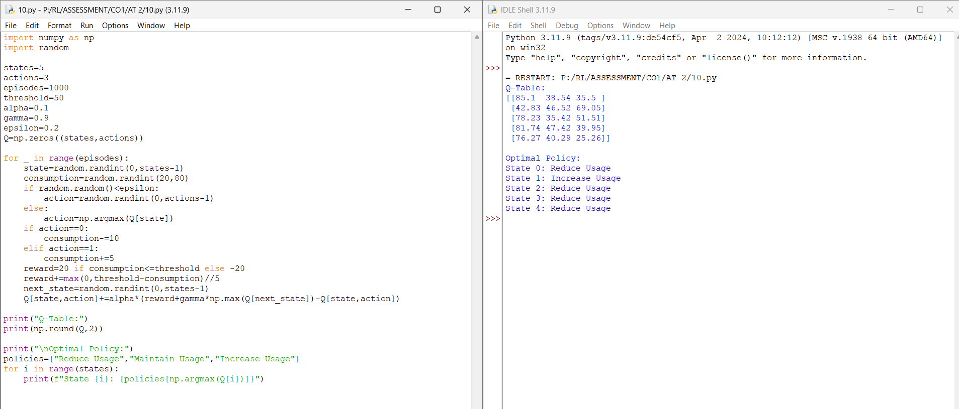Explanation
State Space: Energy consumption levels.
Action Space: Reduce, Maintain or Increase usage.
Reward Function:
• Consumption below threshold: Positive reward.
• Consumption above threshold: Negative reward.
Constraints:
• Consumption must remain below the specified threshold.

Result
The RL agent learned an efficient policy that minimized energy consumption while satisfying the threshold.

